Enter Exit System (BCG Shared Assets) with Realistic Car Controller V3.4

Importing Packages
First, you will need to import latest BCG Shared Assets to your project. It can be found in “For BCG Shared Assets“ folder.

Two new scenes (FPS / TPS) will be added in “Scenes” folder. These scenes have sample FPS / TPS character controllers.

You can edit some settings from (Tools BCG Shared Assets Edit Settings).

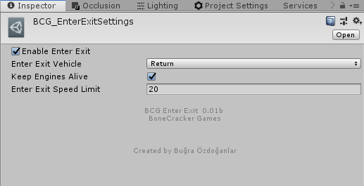

How does it work?
FPS and TPS scenes have “_BCGEnterExitManager” gameobject with script attached to it. It will be created automatically if your scene has any vehicle or character with enter / exit script. This manager script is enabling / disabling character controller on enter / exit. And enabling / disabling controllable state of the vehicle with RCC camera.

Each vehicle must have “BCG_EnterExitVehicle” script attached. And character controller must have “BCG_EnterExitFPS” or “BCG_EnterExitTPS” script attached. You can simply add it from Tools BCG Shared Assets Enter-Exit Add…
